# STM32WL Sensor Node – Schematics, 3D PCB Render, and Layout Overview

# This document presents the core hardware design files for the STM32WL-based wireless sensing platform. It includes:

# • Schematic diagrams of the system

# • 3D render of the PCB

# • PCB Layout (multiple Layers)

# The design integrates a low-noise analog front end (AFE), LoRa RF communication, and STM32WL microcontroller for signal acquisition and wireless transmission.

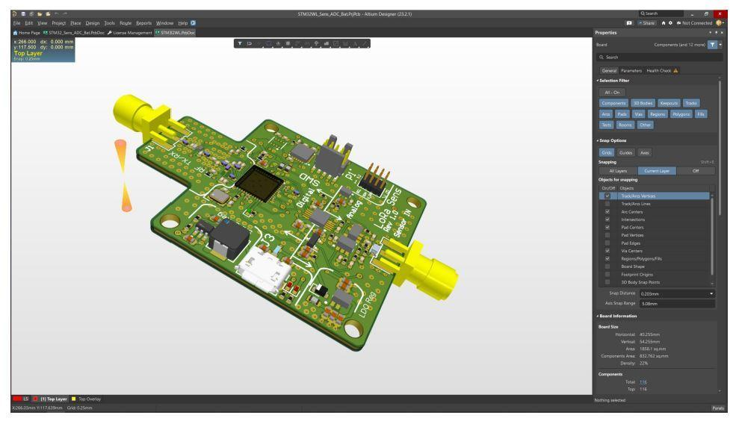

**Figure 1: 3D Render of PCB (Altium View)**

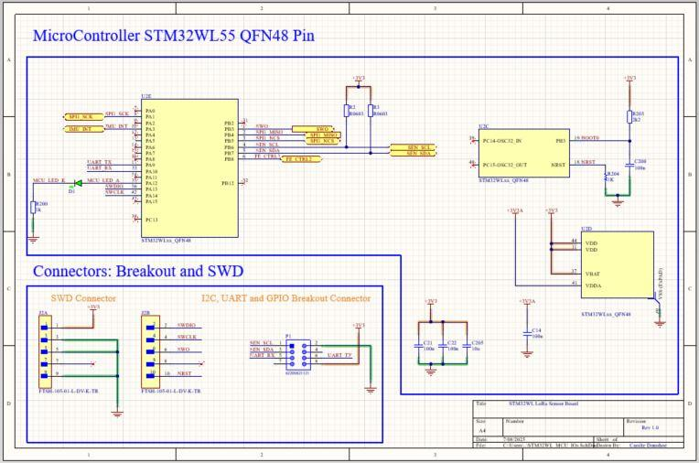

**Figure 2: Microcontroller & SWD Connector Schematic**

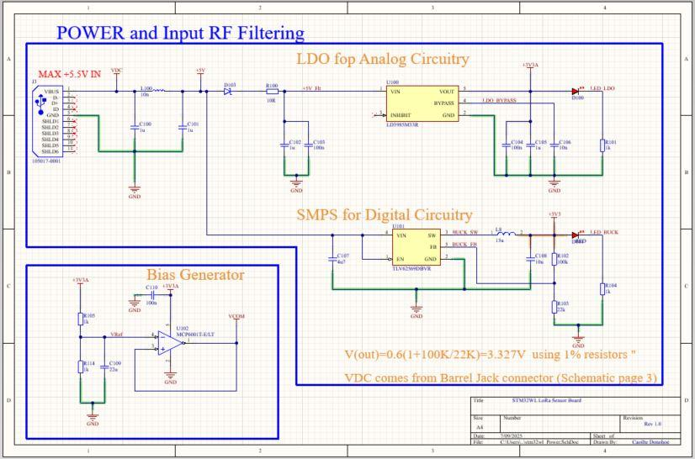

**Figure 3: Power and Input RF Filtering Schematic**

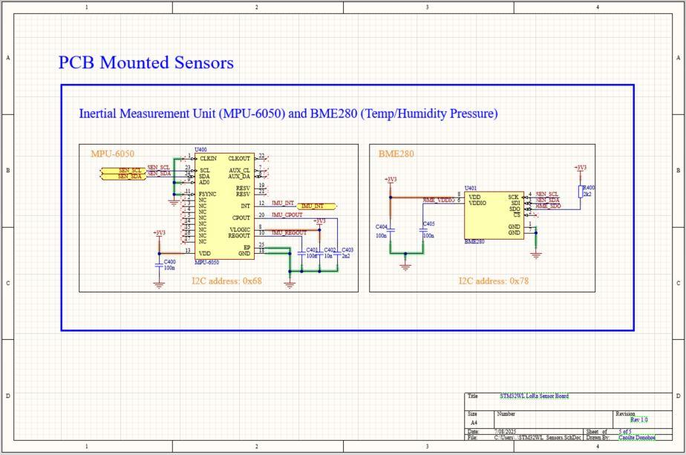

**Figure 4: PCB-Mounted Sensor Schematic (MPU-6050 and BME280)**

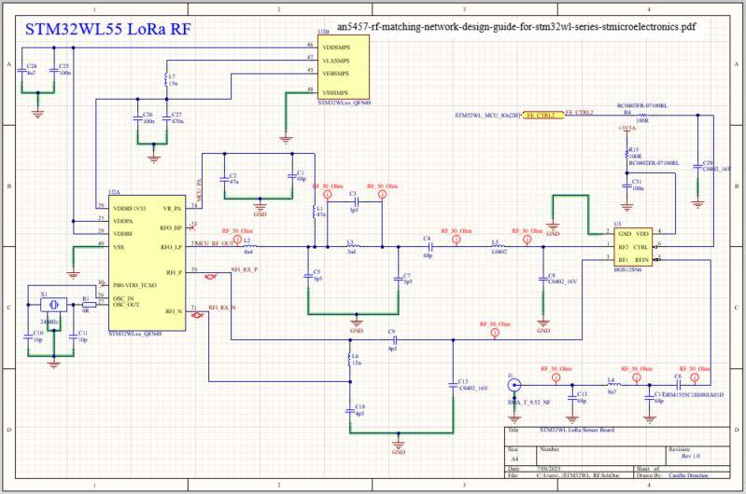

**Figure 5: STM32WL55 LoRa RF Schematic**

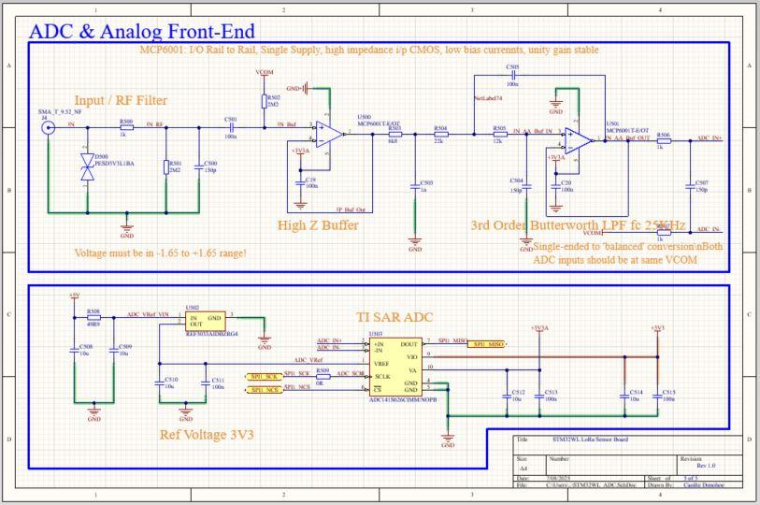

**Figure 6: ADC and Analog Front-End Schematic**

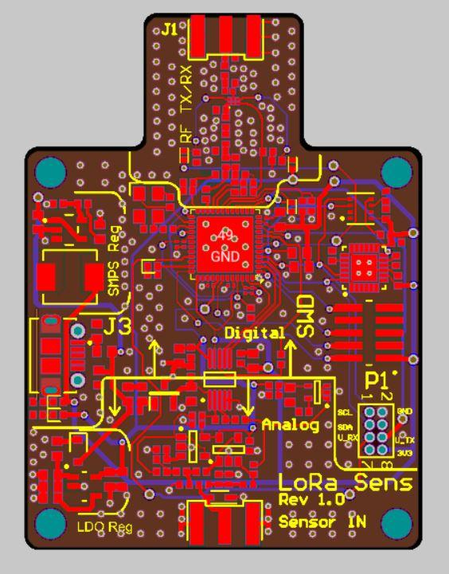

**Figure 7: PCB Top Layer Layout**

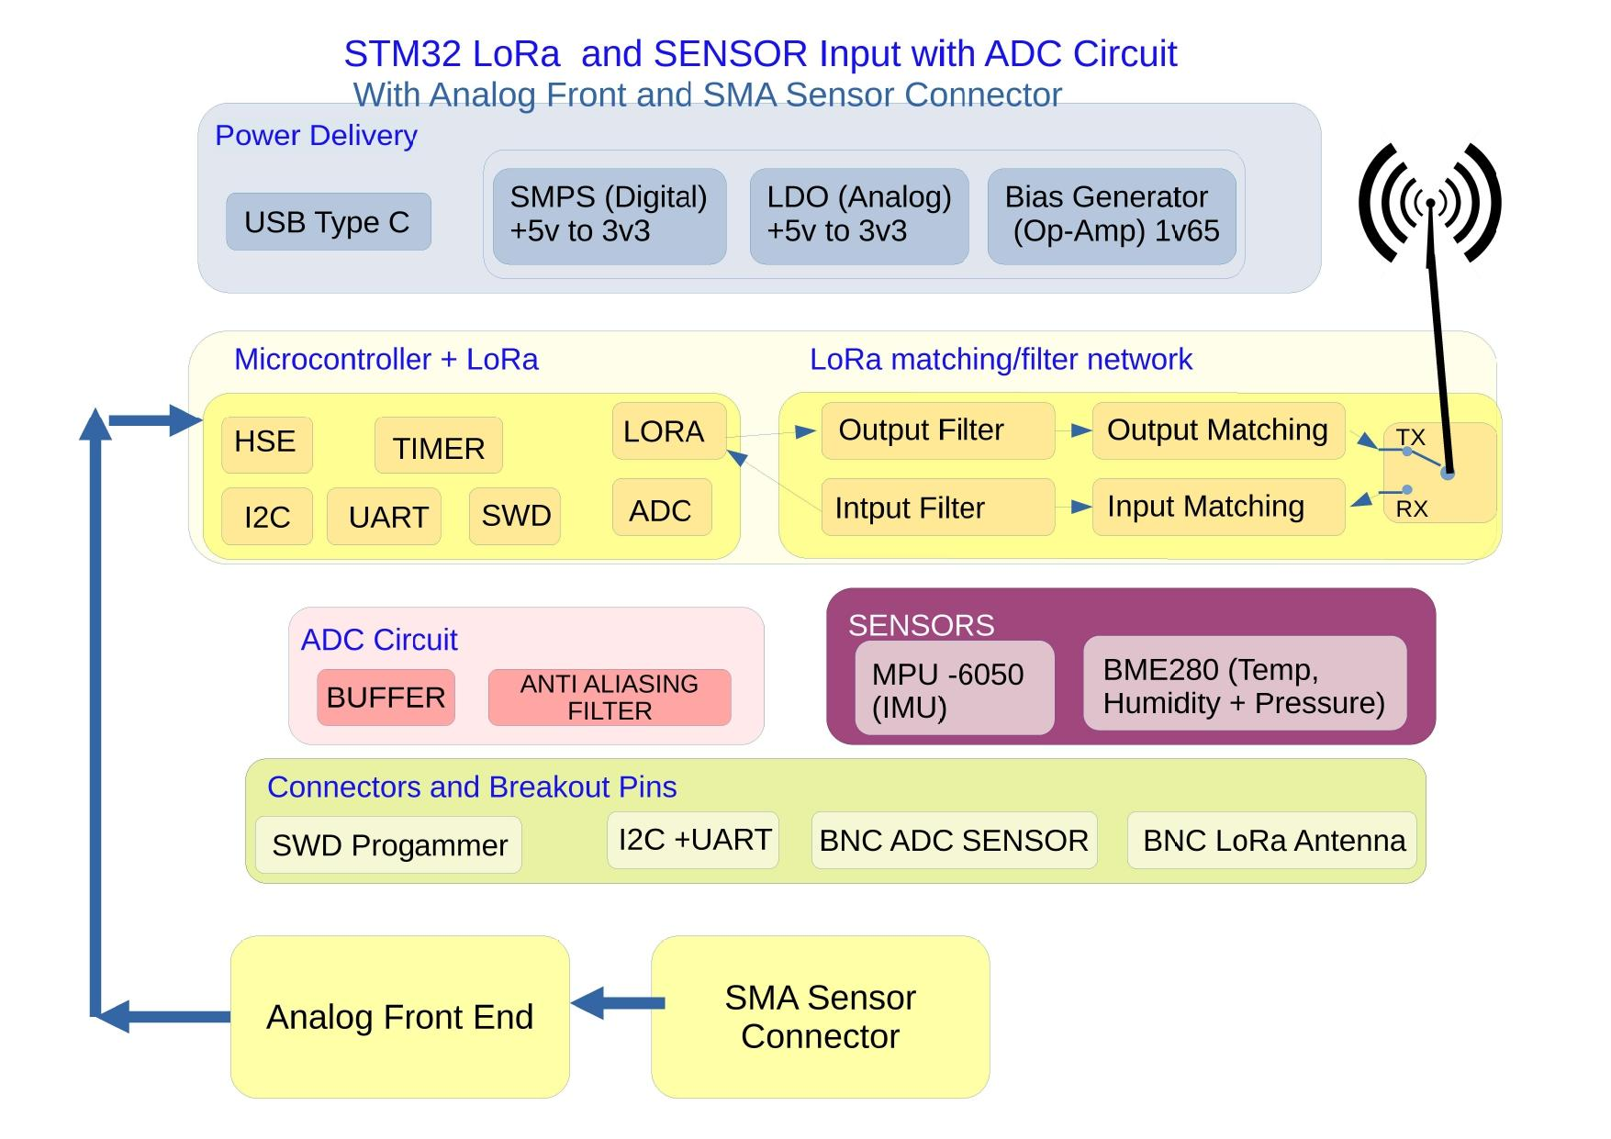

**Figure 8: System Block Diagram – STM32WL with LoRa, Sensor, and ADC Circuit**